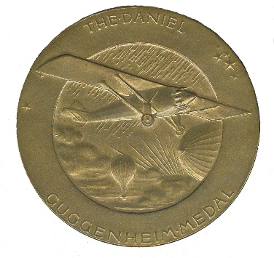

Daniel Guggenheim Medal Award

Nomination Form
Sponsoring Societies:
www.guggenheimmedal.org
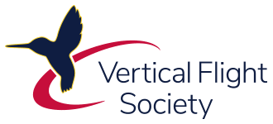

American Institute of Aeronautics and Astronautics (AIAA), American Society of Mechanical Engineers (ASME), SAE International, and the Vertical Flight Society (VFS) are proud to award The Daniel Guggenheim Medal.
The Daniel Guggenheim Medal was established as an international award for the purpose of honoring an individual who makes notable achievements in advancing the safety and practicality of aviation. The Medal recognizes contributions to aeronautical research and education, the development of commercial aircraft and equipment, and the application of aircraft to the economic and social activities of the nation.
To be considered for this award, the nominator must submit nomination online. References are also to submit their endorsements online. It is recommended that the nominator submit this nomination about one month prior to the deadline as it will then give the reference ample time to submit a compelling and thoughtful endorsement. A complete nomination package (nomination plus the required endorsements are due into the online awards system by the deadline of 1 July. Visit the following webpage for details and access to the online system: Guggenheim. This is an annual award.

Self-nominations are not permitted. Guggenheim Board Members cannot act as a nominator or reference to any active Guggenheim nomination. The nominator cannot act as a reference.

The nomination will be considered for a total of three years (the original year plus two subsequent years).

This award will be presented at the annual AIAA Awards Gala in May in Washington, D.C. or at a venue preferred by the award winner.

Death of the candidate subsequent to selection at the meeting of the Board shall not debar said candidate from posthumous Award if the selection is confirmed in regular course by letter-ballot. Such posthumous Award shall consist of a certificate presented to the members of the Medalist’s family.

For more information, please visit www.guggenheimmedal.org or contact The Daniel Guggenheim Board of Award Administrator, the American Institute of Aeronautics and Astronautics, Patricia A. Carr, AIAA, Senior Manager, Honors and Awards Programs, patriciac@aiaa.org

Daniel Guggenheim Medal Award

Nomination Form
Sponsoring Societies:

This Form is used as a draft purpose only
All Nominations and References are to be submitted online

www.guggenheimmedal.org
Nomination Deadline: 1 July
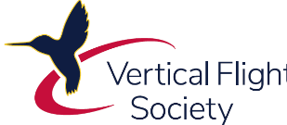

Candidate Information

Date of Submission:

Name
Job Title
Organization
City/State/Zip |  | Country
Telephone |  | Email

Candidate’s Society Affiliation:
- American Institute of Aeronautics and Astronautics
- American Society of Mechanical Engineers
- SAE International
- Vertical Flight Society
- Other
- None

Proposed Citation
In 25 words or less, describe specific accomplishments/activities which are the basis for this award

Reference Information

The nominator is to seek out and confirm the willingness of each reference prior to submitting tis nomination.

The references should draw upon their specific and/or personal knowledge of the candidate.
This endorsement is a 500-word limit in the online text box.

Upon submitting the nomination, the system will send each reference an email. This email will include a link back to the online nomination for their endorsement entry. The nominator does not collect them, nor see this endorsement.

Reference #1: Name
Organization
Email Address

Reference #2: Name
Organization
Email Address

Reference #3: Name
Organization
Email Address

Reference #4: Name (optional)
Organization
Email Address

Reference #5: Name (optional)
Organization
Email Address

BASIS FOR AWARD
Describe the accomplishments and/or contributions of the nominee which are the basis for this award nomination. Please summarize and/or list specific examples of the candidate’s contributions to advancing the safety and practicality of aviation through aeronautical research and education, the development of commercial aircraft and equipment, and the application of aircraft to the economic and social activities of the nation.

(1000-word limit)

BASIS FOR AWARD

RESUME OR BIO
Please provide a resume or bio of the candidate’s professional record, including education, leadership and management positions, and technical honors and awards.

(1000-word limit)

