**Email Signature Template**

Promote your Section events or other Section programs with these customizable email signature graphics. Two examples promoting AIAA membership are provided, which can be completely customized for your needs.

**To access and edit the image files, you will need a FREE Canva account.**

[**Click this link >>**](https://www.canva.com/design/DAGH2sX1uZc/i44paeS3uzn8BUATGedaiw/view?utm_content=DAGH2sX1uZc&utm_campaign=designshare&utm_medium=link&utm_source=publishsharelink&mode=preview) to access the AIAA email signature image files, then click the “Use template for new design” button at the bottom of your screen. This will prompt you to log in or create a new Canva account.

Once you’ve logged in and accessed the template, you’ll see the images within the “Recent Designs” section of your Canva account. Add your event details or other promotional information in the text areas.

When your design is complete, click the “Share” button in the top-right of your screen, then select “Download” from the drop-down menu. Select “PNG” as the file type on the next screen (this should be the default) and which file you want to download in the “Select pages” section, then click “Download” to save the files to your computer.

The following pages contain a visual preview of the images within the Canva template.

Email Signature Graphic Template 1:

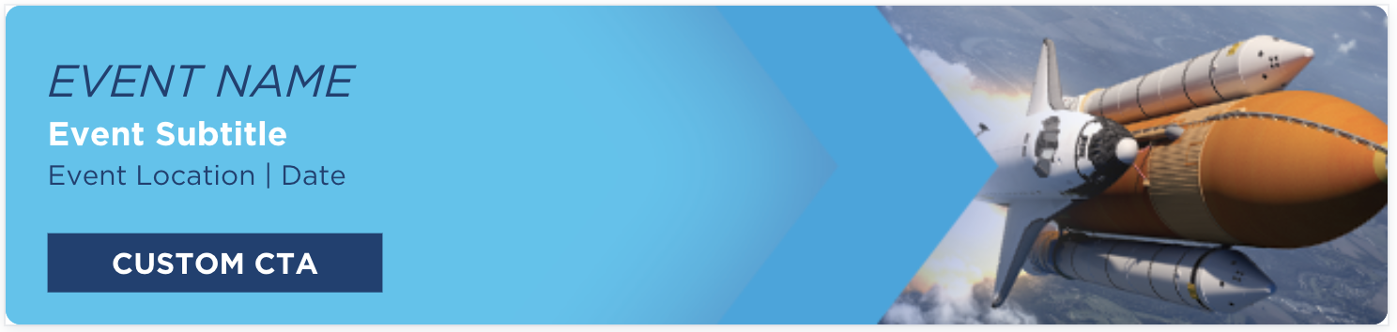

Email Signature Graphic Template 2:

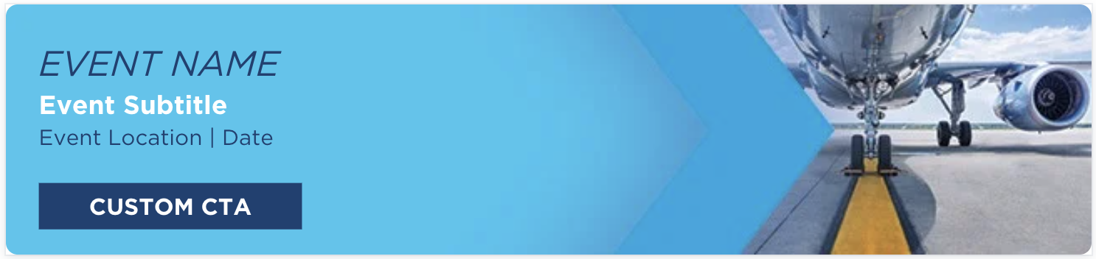

Email Signature Graphic Template 3:



Completed Graphic with Event Details Example 1:



Completed Graphic With Event Details Example 2, including adaptations to accommodate event details:



Example of a promotional graphic embedded within an email signature:

