Newsletter Email Template

To keep local members engaged, we recommend sending a newsletter once a quarter. Leverage the following newsletter email template to help guide your content development so you’re showcasing the most relevant and timely Section activities and AIAA opportunities. The newsletter is intended to be customized.

Subject Line & Preheader Text:

Select one of the following recommended subject line and preheader options for your email. See the below image for contextual reference. If sending these emails via a personal email (e.g., Gmail, Outlook), the preheader text may be omitted.

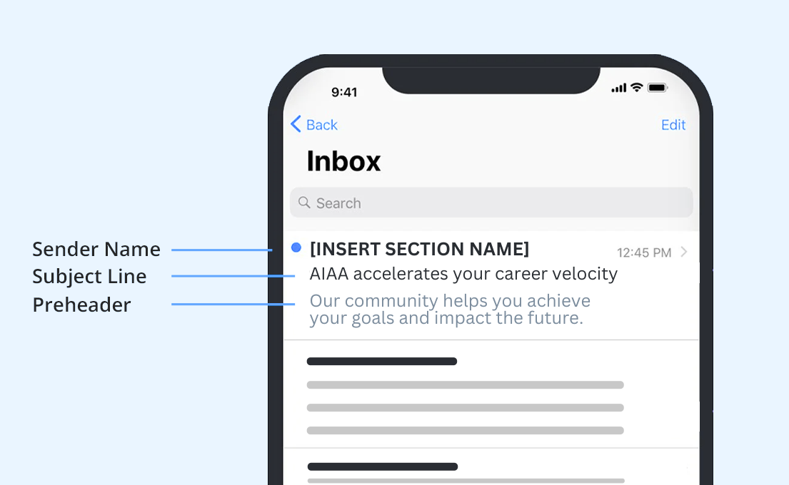

Subject / Preheader Option 1:

SUBJECT LINE 1: In Your Orbit
PREHEADER 1: The Latest News in ((Drop in Section Name))

Subject / Preheader Option 2:

SUBJECT LINE 2: Crew Briefing
PREHEADER 2: What's New in ((Drop in Section Name))

Subject / Preheader Option 3:

SUBJECT LINE 3: Our Space
PREHEADER 3: The Quarterly Newsletter for AIAA ((Drop in Section Name))

Subject / Preheader Option 4:

SUBJECT LINE 2: From the Flight Deck
PREHEADER 2: Here’s What’s Happening in ((Drop in Section Name))

RECOMMENDED NEWSLETTER STRUCTURE

Use the following outline of email segment ideas and prompts to guide your newsletter development, ensuring that it’s engaging and highlighting the most pertinent information. Email segments can be omitted as needed based on relevancy.

Headline:

Select a headline for your newsletter that matches your chosen email subject line.

Headline Option 1:
In Your Orbit

Headline Option 2:
Crew Briefing

Headline Option 3:
Our Space

Headline Option 4:
From the Flight Deck

Segment 1: Lead Story

Customize this segment with a main story/focus of the newsletter. This should include an important announcement that warrants the top placement such as Section leadership recruitment, local volunteer opportunities, promoting an upcoming event or recapping a recent event. What you highlight here may impact how you format the rest of the newsletter and decide which segments to include or omit.

Include in this segment:
- A subheadline, such as one of the following options:
  - Ready for Liftoff
  - Airborne
- 1 supporting image
- 1-2 short paragraphs
- 1 call-to-action link (e.g., Learn More, Register Now, Sign Up)

Segment 2: Note from the Chair

Customize with chair’s letter. This is meant to be a personal note from the Section chair so it should feel welcoming, celebratory and evoke excitement. This letter could be approached as the lead story and take the top placement instead, if it makes sense for the primary focus of your newsletter.

Include in this segment:
- A subheadline, such as one of the following options:
  - Command Module
  - In the Cockpit
- 1 supporting image
- 1-2 short paragraphs
- 1 call-to-action link (e.g., Learn More, Register Now, Sign Up)

Segment 3: Upcoming Section Events

Customize with AIAA’s national events and local section events. Events should be listed chronologically and formatted as outlined below with an opportunity to highlight one event at the top of the list. The featured event should bring attention to a local event or highlight the next upcoming national AIAA event. Please refer to the event webpage for the most up to date information.

Include in this segment:
- A subheadline, such as one of the following options:
  - In the Atmosphere
  - Local Logbook
- Event details, using the following format:

FEATURED EVENT:
2024 AIAA AVIATION Forum
29 July – 2 August 2024
Las Vegas, Nevada
Register Now

Add Event Name
Start Date – End Date
City, State
Register Now

Segment 4: Volunteer Opportunities

Customize with open volunteer opportunities such as STEM education programs, contests, events, etc. This segment should clearly communicate the expected time commitment, any key requirements for volunteers and next steps for getting involved.

Include in this segment:
- A subheadline, such as:
  - Join the Mission
- Time Commitment (Dates or approximate time each week/month)
- 1-2 sentences covering any requirements and next steps for confirming interest or applying
- 1 call-to-action link (e.g., Learn More, Sign Up)

Segment 5: Member Announcements

Customize with news of member achievements such as student scholarships, contest/award winners or noteworthy career advancements. Recognizing local members is a great way to increase engagement within your Section. If there’s no news to add here, the “share an achievement” CTA copy is helpful to include so you can aggregate a list of achievements to highlight in your next newsletter.

Include in this segment:
- A subheadline, such as one of the following options:
  - (Inter)Stellar Accomplishments
  - Earning Their Wings
- Headshot of member
- First Name, Last Name, Name of Award or Achievement
- 1-2 sentences sharing an overview
- Call to action paragraph:
Do you have an industry accomplishment to highlight? Recognize your member peers (or yourself!) for a recent award, scholarship or career advancement so we can help celebrate. Email ((Insert email address)) to share.

Segment 6: Connect With Us

Drop in officer or committee contact info, as well as dedicated social links or AIAA’s social links using the following format:

Section Position
First/Last Name, email address

Facebook: https://www.facebook.com/AIAAfan
X: https://twitter.com/aiaa
LinkedIn: https://www.linkedin.com/company/aiaa
Instagram: https://www.instagram.com/aiaaerospace/
YouTube: https://www.youtube.com/channel/UCQUxcIsXCZuwCa34u1J5COw

Segment 7: Closing

Customize the following closing segment with your Section information.

Follow ((Drop in Section Name and Engage Community URL)) on the AIAA Engage platform to stay connected with your local aerospace members.

Reach out to us at ((Drop in Email Address)) to learn how you can get more involved.

Thank you for being part of the AIAA community!

The following pages contain a visual preview of what a full Section newsletter containing all seven segments might look like using an email platform such as Hubspot.

Example Newsletter, Full View: Example Newsletter Part 1, Zoomed In:
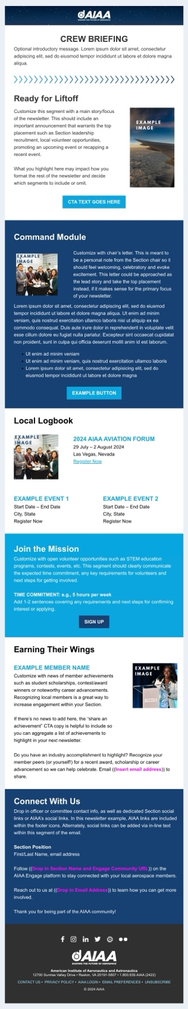
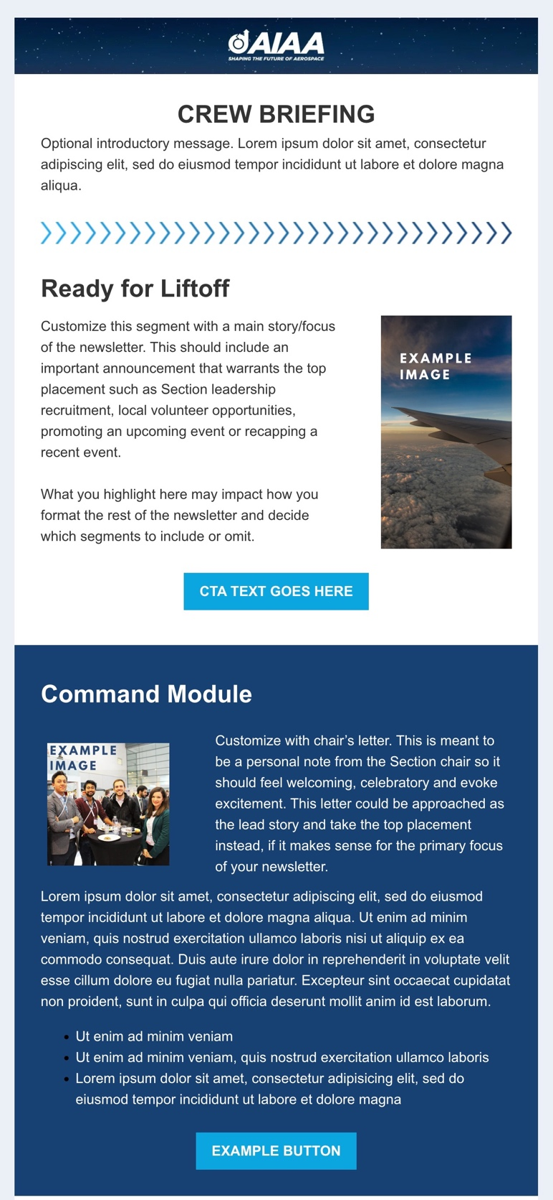

Example Part 2, Zoomed In: Example Part 3, Zoomed In:
