Onboarding Email for New Educator Associate Members

The following email drafts is designed to support onboarding new AIAA Educator Associate members to your section. We recommend sending the onboarding email approximately two weeks after a member is assigned to your section. The recommended text can be updated as needed to suit your section details and local membership activities.

Subject Line & Preheader Text:

Select one of the following recommended subject line and preheader options for your email. See the below image for contextual reference. If sending these emails via a personal email (e.g., Gmail, Outlook), the preheader text may be omitted.

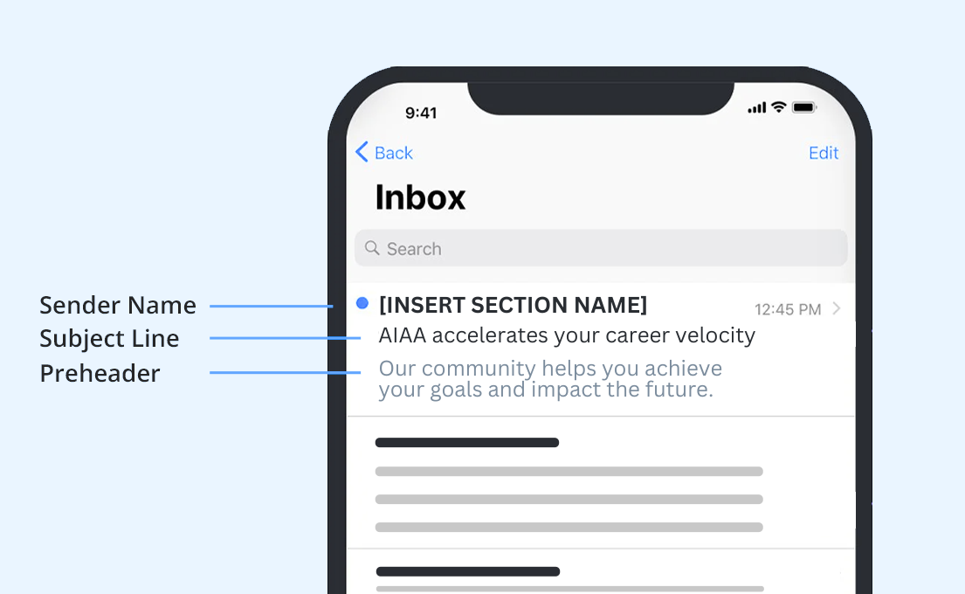

Subject / Preheader Option 1:

SUBJECT LINE 1: Launch your students’ aerospace careers!
PREHEADER 1: See how our membership tools can help you inspire the next generation.

Subject / Preheader Option 2:

SUBJECT LINE 2: A universe of possibilities awaits...
PREHEADER 2: Help your students fulfill their aerospace dreams.

Recommended Email Body Text:

Hi ((First Name)),

We’re excited to welcome you as an AIAA Educator Associate Member in ((Drop in Section or Region)). We hope you enjoy this special complimentary membership for K-12 educators.

As someone responsible for shaping young minds and helping students realize their potential, you have an important job — and your membership tools will make that job easier:

- ((Insert specialized section content here and/or use the following benefit list))
- Find inspiration and ideas in Aerospace America, our member-exclusive magazine.
- Connect and collaborate with other innovative members at AIAA forums and section events, and through the global AIAA Engage community.
- Fuel your students’ curiosity and knowledge with online educator resources.
- Get much-needed STEM supplies by applying for an AIAA Foundation Classroom Grant.
- Gain recognition with an AIAA Foundation Educator Achievement Award.

The sky’s not the limit when you are motivating your students and encouraging their aspirations. Start exploring your AIAA resources today, and reach out to us with any questions!

((Insert your AIAA email signature))

