Onboarding Email for New University Student Members

The following email drafts is designed to support onboarding new AIAA University Student members to your section. We recommend sending the onboarding email approximately two weeks after a member is assigned to your section. The recommended text can be updated as needed to suit your section details and local membership activities.

Subject Line & Preheader Text:

Select one of the following recommended subject line and preheader options for your email. See the below image for contextual reference. If sending these emails via a personal email (e.g., Gmail, Outlook), the preheader text may be omitted.

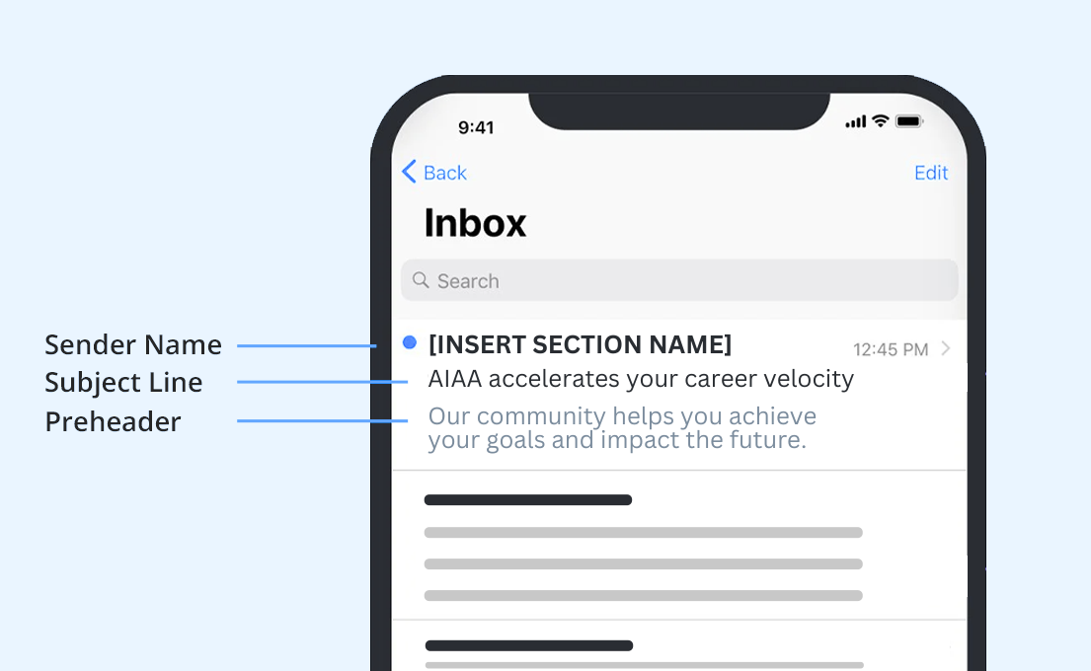

Subject / Preheader Option 1:

SUBJECT LINE 1: AIAA membership hits different…
PREHEADER 1: You won’t find these career-building tools anywhere else.

Subject / Preheader Option 2:

SUBJECT LINE 2: Only one membership boosts your career (IYKYK)
PREHEADER 2: You’ve got access to exclusive resources. Now make the most of them.

Recommended Email Body Text:

Hi ((First Name)),

I’m excited to welcome you as an AIAA Student Member in ((Drop in Section or Region)).

It’s the ideal launchpad for your aerospace career because you can access valuable professional development resources:

((Insert specialized section content here and/or use the following benefit list. Emojis may be replaced with bullet points if preferred.))
Jumpstart your trajectory with AIAA Career Center’s job listings and mentorships.
Start building your network with your university peers on the AIAA Discord Server, at local meetups, through the global AIAA Engage platform and in our student communities at almost 200 campuses worldwide.
Discover undergrad and graduate scholarships.
Showcase your skills in design/build/fly competitions.
📰 Stay in the loop on the latest aerospace news in My Daily Launch.
Find career inspiration in Aerospace America, our member-exclusive magazine.
Save money while meeting industry leaders at AIAA events and forums.
📚 Expand your knowledge with discounts on aerospace publications and subscriptions.
Strengthen your leadership skills with our volunteer programs and opportunities to present at AIAA’s Regional Student Paper Conference.

It’s time for career liftoff. Start exploring your AIAA resources today, and reach out to us with any questions!

((Insert your AIAA email signature))

