Onboarding Email for New Young Professional Members

The following email drafts is designed to support onboarding new AIAA Young Professional members to your section. We recommend sending the onboarding email approximately two weeks after a member is assigned to your section. The recommended text can be updated as needed to suit your section details and local membership activities.

Subject Line & Preheader Text:

Select one of the following recommended subject line and preheader options for your email. See the below image for contextual reference. If sending these emails via a personal email (e.g., Gmail, Outlook), the preheader text may be omitted.

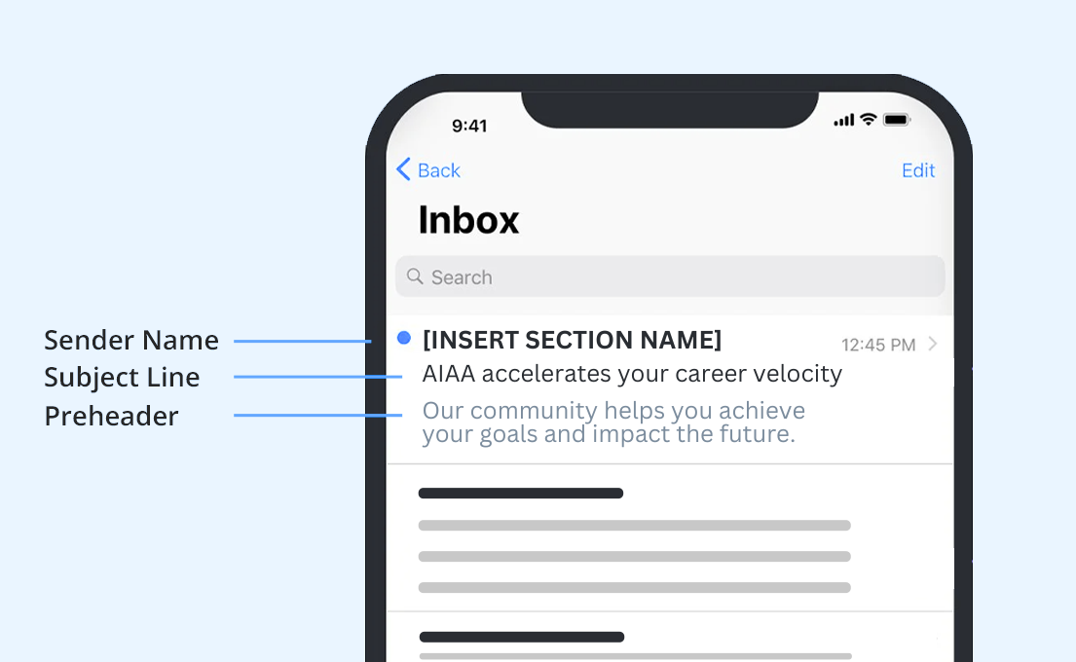

Subject / Preheader Option 1:

SUBJECT LINE 1: With AIAA, you are go for launch!
PREHEADER 1: Time to reach new heights in your aerospace career.

Subject / Preheader Option 2:

SUBJECT LINE 2: AIAA accelerates your career velocity!
PREHEADER 2: Our community helps you achieve your goals and impact the future.

Recommended Email Body Text:

Hi ((First Name)),

I’m excited to welcome you as an AIAA Young Professional Member in ((Drop in Section or Region)).

With the tools and resources available to you, it’s easy to reach for the stars — and your biggest career goals:

- ((Insert specialized section content here and/or use the following benefit list))
- Get all the aerospace news you need to know in My Daily Launch.
- Find career inspiration in Aerospace America, our member-exclusive magazine.
- Access job listings in the AIAA Career Center.
- Collaborate with your peers and industry leaders worldwide through AIAA Engage or make connections in your area during local meetups.
- Hone your leadership skills by participating in AIAA volunteer opportunities.
- Present your research to a wide audience with our technical programs.
- Expand your knowledge with expert-led live or on-demand courses.
- Save money on industry publications and subscriptions.
- Enjoy discounts on skill- and network-building AIAA events and seminars.

It’s time for liftoff. Start exploring your AIAA resources today, and reach out to us with any questions!

((Insert your AIAA email signature))

