Postcard Template

Promote membership renewal for your Section with this customizable postcard template, which includes two options for the front of the postcard and one for the back.

To access and edit the image files, you will need a FREE Canva account.

Click this link >> to access the AIAA postcard files, then click the “Use template for new design” button at the bottom of your screen. This will prompt you to log in or create a new Canva account.

Once you’ve logged in and accessed the template, you’ll see the images within the “Recent Designs” section of your Canva account. Add your section name to one of the Postcard Front options and replace all the pink text on the Postcard Back with your Section’s mailing address, Section name, email address, and Section Chair details. If the text of the postcard is revised, be sure to avoid placing any text over the pink backgrounds. Those areas must stay blank for printing.

When preparing for print, delete all the pink background color blocks and white text on the Postcard Back prior to printing — those are only shown to indicate placement for the recipient’s mailing address and postage, as well as areas where text or design elements cannot be placed.

When your design is complete, click the “Share” button in the top-right of your screen, then select “Download” from the drop-down menu. Select “PNG” as the file type on the next screen (this should be the default) and which files you want to download in the “Select pages” section, then click “Download” to save the files to your computer.

For printing and mailing, Canva has a “Print with Canva” option, but the downloaded image files can be used with any print provider such as Vistaprint. Be sure to select the 4x6 inch size product option to avoid any potential resizing issues.

The following pages contain a visual preview of the images within the Canva template.

Postcard Front Option 1:


Postcard Front Option 2:


Postcard Back — pink text must be updated and pink backgrounds must be deleted prior to downloading for print:
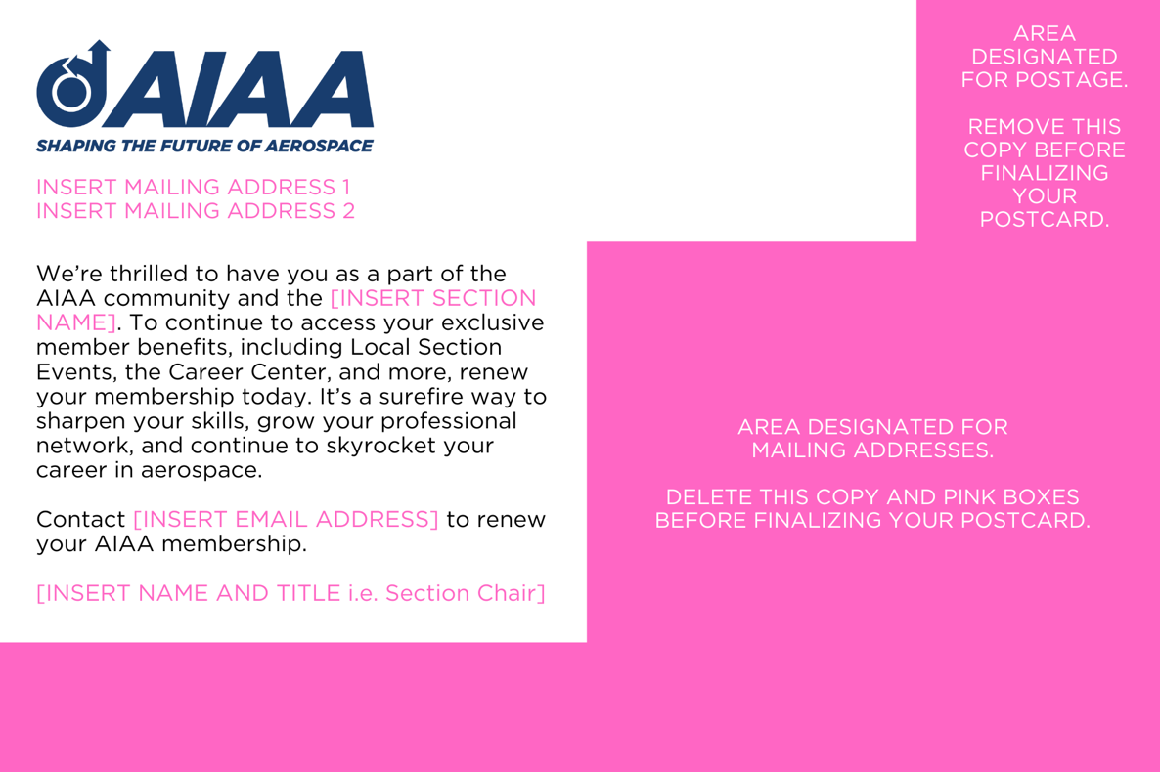

When preparing for print, the pink-background areas should look something like this:
