Recruitment Email for Professionals

The following email draft is designed to help you follow up with professional event attendees who are NOT currently AIAA members. Update the text as needed to suit your event and section details.

Subject Line & Preheader Text:

Select one of the following recommended subject line and preheader options for your email. See the below image for contextual reference. If sending these emails via a personal email (e.g., Gmail, Outlook), the preheader text may be omitted.

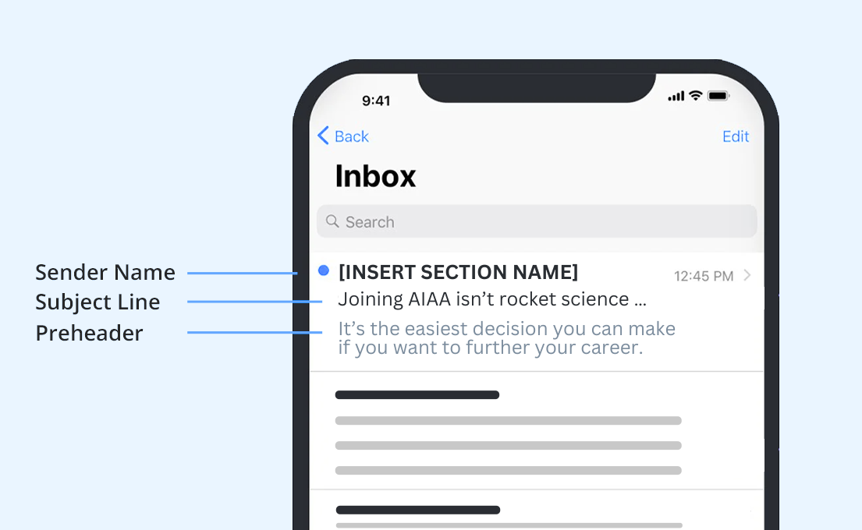

Subject / Preheader Option 1:

SUBJECT LINE 1: Joining AIAA isn’t rocket science …
PREHEADER 1: It’s the easiest decision you can make if you want to further your career.

Subject / Preheader Option 2:

SUBJECT LINE 2: Propel your potential with AIAA
PREHEADER 2: Join AIAA and discover how you can reach new heights in your career.

Recommended Email Body Text:

Hi ((First Name)),

Thank you for attending ((Drop in Name of Event)). Now that you’ve experienced the AIAA community, why not be part of it? This is where you can further your career while advancing the future of aerospace.

When you join as a Professional Member, your benefits — and your opportunities — are infinite. You’ll enjoy lower prices for AIAA events and seminars where you can expand your network as you connect with leaders in the field. Local meetups such as ((Insert Upcoming Section Events)) and volunteer opportunities allow you to collaborate with your peers.

And it doesn’t stop there: You’ll be at the forefront of the industry’s latest developments with My Daily Launch and the members-only magazine Aerospace America. You can also hone your expertise with online courses, publications and subscriptions (many of which are available at discounted rates).

Aim for the stratosphere and see what you can accomplish as an AIAA member. Join today!

((Insert your AIAA email signature))

