Recruitment Email for University Students

The following email draft is designed to help you follow up with university student event attendees who are NOT currently AIAA members. Update the text as needed to suit your event and section details.

Subject Line & Preheader Text:

Select one of the following recommended subject line and preheader options for your email. See the below image for contextual reference. If sending these emails via a personal email (e.g., Gmail, Outlook), the preheader text may be omitted.

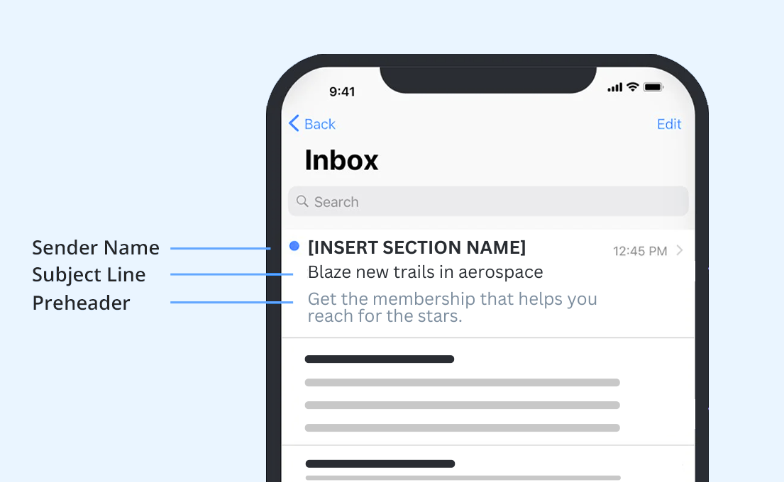

Subject / Preheader Option 1:

SUBJECT LINE 1: Your aerospace future starts here, no cap
PREHEADER 1: AIAA resources will help your new career take flight.

Subject / Preheader Option 2:

SUBJECT LINE 2: Blaze new trails in aerospace
PREHEADER 2: Get the membership that helps you reach for the stars.

Recommended Email Body Text:

Hi ((First Name)),

Thank you for attending ((Drop in Name of Event)). Now that you’ve experienced the AIAA community, why not be part of it? As a Student Member, you’ll access the tools you need for a successful career launch:

- Jumpstart your trajectory and expand your network with the AIAA Career Center, local meetups such as ((Insert Upcoming Section Events)) and volunteer opportunities.
- Earn money for college with scholarship opportunities.
- Start networking with your college peers now on the official AIAA Discord Server and at one of our nearly 200 campus communities worldwide.
- Stay on top of the latest industry news with My Daily Launch and the members-only magazine Aerospace America.

Aim for the stratosphere and see what you can accomplish as an AIAA member. Join today!

((Insert your AIAA email signature))

