Recruitment Email for Young Professionals

The following email draft is designed to help you follow up with young professional event attendees who are NOT currently AIAA members. Update the text as needed to suit your event and section details.

Subject Line & Preheader Text:

Select one of the following recommended subject line and preheader options for your email. See the below image for contextual reference. If sending these emails via a personal email (e.g., Gmail, Outlook), the preheader text may be omitted.

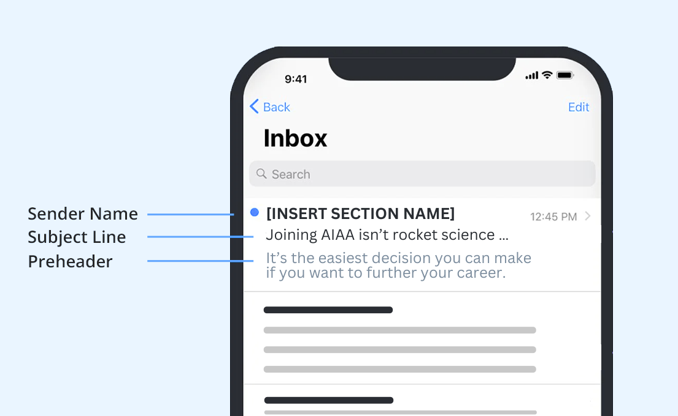

Subject / Preheader Option 1:

SUBJECT LINE 1: Joining AIAA isn’t rocket science …
PREHEADER 1: It’s the easiest decision you can make if you want to further your career.

Subject / Preheader Option 2:

SUBJECT LINE 2: Propel your potential with AIAA
PREHEADER 2: Join AIAA and discover how you can reach new heights in your career.

Recommended Email Body Text:

Hi ((First Name)),

Thank you for attending ((Drop in Name of Event)). Now that you’ve experienced the AIAA community, why not be part of it? This is where you can fulfill your highest ambitions and establish yourself as a shining star in the aerospace industry.

As a Young Professional member, you’ll access infinite benefits — and opportunities:

- Expand your network as you connect with leaders in the field at AIAA events, local meetups such as ((Insert Upcoming Section Events)) and volunteer opportunities.
- Stay on top of the latest industry news with My Daily Launch and the members-only magazine Aerospace America.
- Find your next important job at the AIAA Career Center.
- Hone your expertise with online courses, publications and subscriptions (many of which are available at discounted rates).

Aim for the stratosphere and see what you can accomplish as an AIAA member. Join today!

((Insert your AIAA email signature))

