Social Media Image Template

Promote your Section events, Section membership, and any other Section programs with these customizable social media graphics. Two examples promoting AIAA membership are provided, as well as a blank template that can be completely customized for your needs.

To access and edit the image files, you will need a FREE Canva account.

Click this link >> to access the AIAA social media image files, then click the “Use template for new design” button at the bottom of your screen. This will prompt you to log in or create a new Canva account.

Once you’ve logged in and accessed the template, you’ll see the images within the “Recent Designs” section of your Canva account. Add your section name to the first two images or design a new graphic using the blank template.

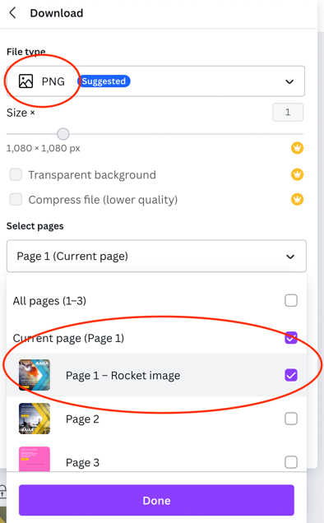
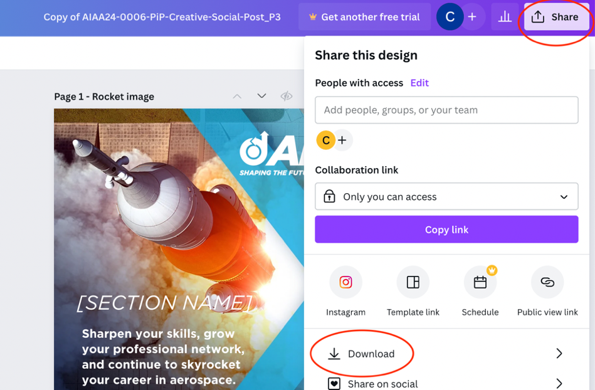
When your design is complete, click the “Share” button in the top-right of your screen, then select “Download” from the drop-down menu. Select “PNG” as the file type on the next screen (this should be the default) and which file you want to download in the “Select pages” section, then click “Download” to save the files to your computer.

The following pages contain a visual preview of the images within the Canva template.

Social Graphic Example 1: Social Graphic Example 2:




Blank Example — Replace the pink background with your own Section image and replace the text with your own message and call-to-action:

