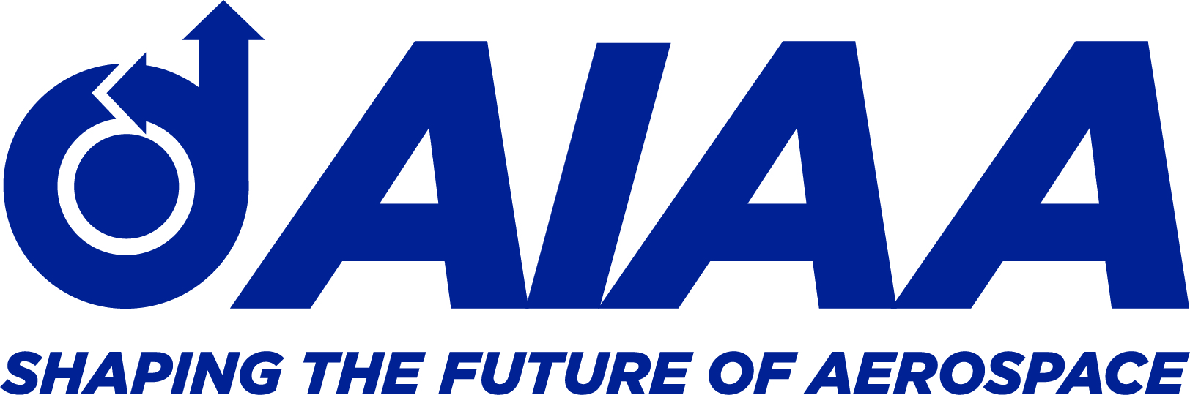

TO: [Staffer’s Email]

FROM: [Your Email]
SUBJECT LINE: Virtual Meeting Request Week of March 14 – American Institute of Aeronautics and Astronautics

Dear [Staffer’s Name]:

I am a member of the American Institute of Aeronautics and Astronautics (AIAA), and I will be representing the organization during its Congressional Visits Day (CVD) program. As a [state resident/constituent] I would appreciate the opportunity to schedule a 20 to 30-minute virtual meeting with you the week of March 14.

CVD is an annual event that gathers engineers, scientists, researchers, and students for a discussion with national decision makers about the critical community issues in civil aeronautics, civil astronautics, and defense. The event raises awareness of the long-term value that science, engineering, and technology bring to America. And this year CVD participants will address the needs of the resilient aerospace and defense industry, as it will be an essential part of our nation’s rapid recovery from the COVID-19 pandemic.

Headquartered in Reston, Virginia, The American Institute of Aeronautics and Astronautics (AIAA) is the world’s largest aerospace technical society. With nearly 30,000 individual members from 91 countries, and 100 corporate members, AIAA brings together industry, academia, and government to advance engineering and science in aviation, space, and defense.
Thank you in advance for considering my request to schedule a virtual meeting the week of March 14. I look forward to hearing from you as soon as possible. You may reach me by telephone at XXX-XXX-XXXX or by email at XXXX@XXXXX.XXX.

Regards,

[Name]

