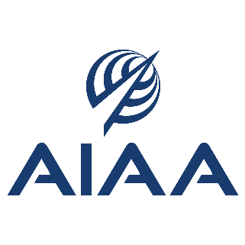

AIAA FELLOW
REFERENCE FORM

** CONFIDENTIAL **

DUE: JULY 1
ONLINE ONLY

AIAA CONSTITUTION
Article III, Section 3.2

Fellows shall be persons of distinction in aeronautics or astronautics,
and shall have made notable and valuable contributions to the arts, sciences or technology thereof.

AIAA BYLAWS
Section 2.4

Nominees for Fellow must be Associate Fellows of the Institute in good standing. One Fellow for every one hundred twenty-five (125) Associate Fellows determines the number of Fellows per year. The most qualified nominees shall be submitted by the Honors and Awards Committee to the Board of Trustees for final approval. The Fellows nomination and selection process shall be established by the Honors and Awards Committee, specified in the Committee’s published policies and procedures.

You will receive an email requesting your endorsement.
In this email is a unique link back to the online nomination.
When you click on this link, the system will populate your name and other member information.

RECOMMENDATION: Draft your endorsement first on this word document and when ready, copy into the online endorsement box. Once you click on the “Save” button, it will officially submit the endorsement and no further changes can be made.

If you would like a copy of the nomination, please contact the nominator.

- Peer Reviwers are looking for additional information than what is written in the nomination. Do not copy/paste nomination information into your reference. This will be a deduction in points.

- References are a key element of the nomination package.

- References should be very familiar with the nominee and his/her contributions to validate the accuracy of the information contained in the nomination package and to provide independent judgment of the merit of the nominee’s selection to become an Associate Fellow.

- References should provide their prospective why the candidate should become an AIAA Fellow. Pease do not repeat or copy/paste information noedinthe nomination.

Instructions for your Endorsement:

Evaluate the impact the nominee’s contributions have had on the aerospace body of knowledge, the aerospace profession or industry, and or the development, deployment and operation of aerospace systems

Value Judgement / Overall Impact to the Aerospace Community: (check one)
  - Exceptionally well-qualified for Fellow
- Well-qualified for Fellow
- Marginally qualified for Fellow
- Not qualified for Fellow

This judgment is based upon: (check one)
- Personal knowledge of the nominee
- Knowledge of the nominee’s work
- Both personal knowledge of the nominee and knowledge of the nominee’s work

In answering the following question, please draw upon your specific and/or personal knowledge of the nominee.

Describe the notable technical and/or leadership contributions the nominee has made to the arts, sciences or technology of aeronautics or astronautics; and describe the impact the nominee’s contributions have had on the aerospace body of knowledge, the aerospace profession or industry, and/or the development, deployment and operation of aerospace systems. What do you feel is most important or most significant? Also include specific impacts of the nominees contributions/service to AIAA or other aerospace-related professional organizations in your description. If you have knowledge of something significant that is not in the nomination, please add it here.

500 word limit

